Ideation Phase
Brainstorm & Idea Prioritization Template

Date | 19 February 2026
Team ID | LTVIP2026TMIDS77295
Project Name | Smart Sorting: Transfer Learning for Identifying Rotten Fruits and Vegetables

Brainstorm & Idea Prioritization Template:
Step-1: Team Gathering, Collaboration and Select the Problem Statement
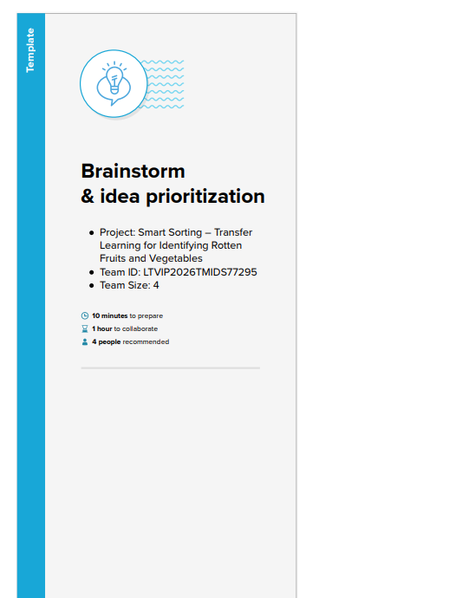
Step-2: Brainstorm, Idea Listing and Grouping
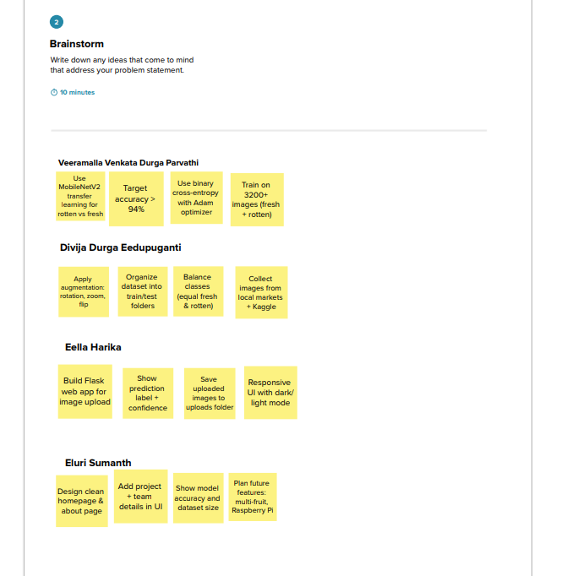
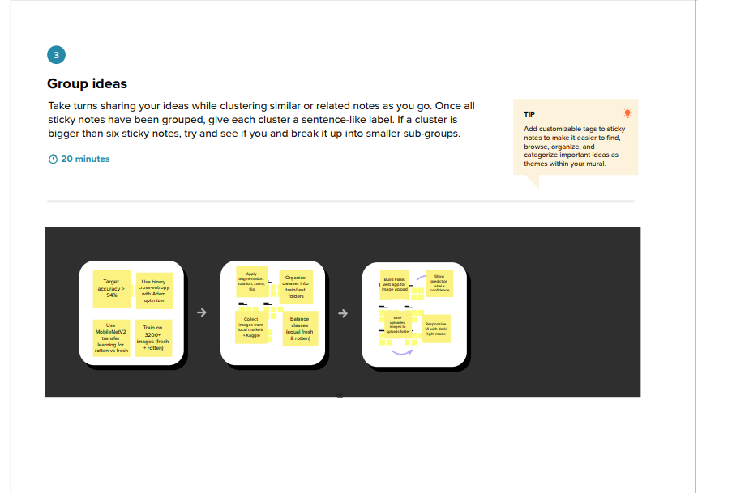
Step-3: Idea Prioritization
